A Team Member’s Guide to Woven

The Basics
Woven is an online tool that we will use to:
- Communicate within our teams and with individuals
- Assign and complete tasks
- Manage time-off requests, missed shifts, and weekly availabilities
- Learn more about company policies
- Reference step-by-step instructions for how to complete tasks
- Identify team members who have specialized skills
- Find links to the most frequently visited websites used for work.

Everyone will get a Woven account username and password. Access Woven on your desktop by visiting https://app.woven.team/Login or download the Woven phone app:
- Download on Android: https://play.google.com/store/apps/details?id=com.lumarc.woven
- Download on iOS: https://itunes.apple.com/us/app/woventeam/id1452397439

Currently, the Woven phone apps only have announcements, direct messaging, and team conversations. It will soon have additional features.

There are four main areas to Woven: your Home Page, Direct Messages, the Team Hub, and the Knowledge Base.

Home Page
Your Woven Home page gives you a set of Quick Actions and shows your Announcements and assigned Tasks.

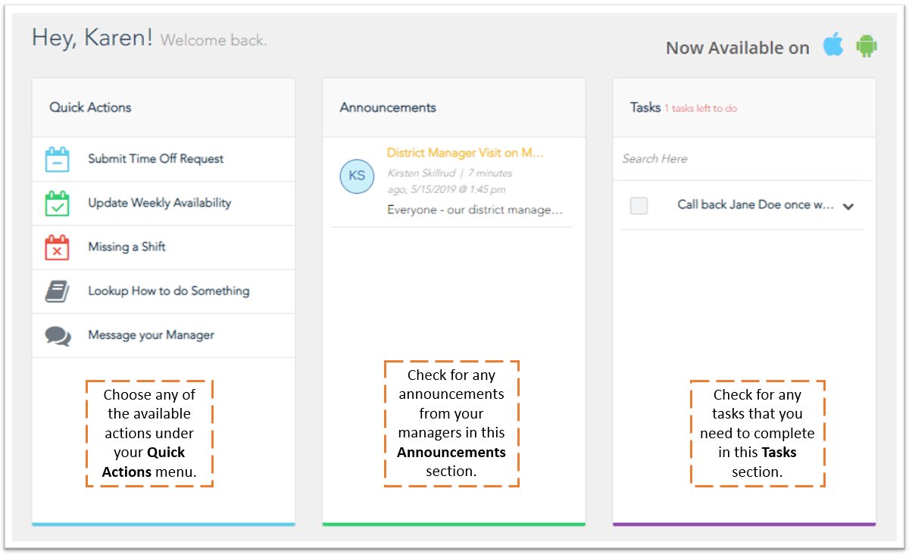

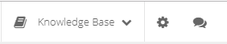
Direct Messages
Click on the Direct Message icon in the upper right-hand corner to
start a conversation with one of your team members – no need to
exchange phone numbers!

Team Hub
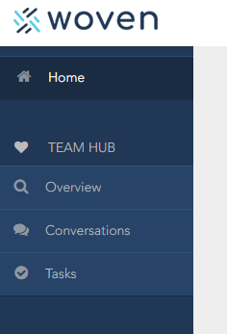
Your Team Hub section appears in the upper left-hand corner. Use
Team Hub to communicate with your team(s) and review tasks
assigned to you and your fellow teammates.

If you are a member of multiple teams, you’ll need to toggle between
your teams using the team drop-down menu located at the top of each
team hub page.

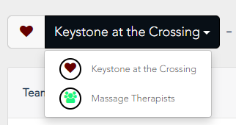

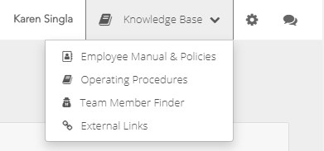
Knowledge Base
Your Knowledge Base section appears in the upper
right-hand corner. Use this section’s options to:
- Learn more about company rules (Employee
Manual & Policies)
- Reference step-by-step instructions for how to
complete tasks (Operating Procedures)
- Identify team members who have specialized
skills (Team Member Finder)
- Find links to the most frequently visited
websites used for work (External Links)

Rules
The following rules will take effect on MM/DD/YYYY:
- Team members must log into Woven daily excluding the non-working days
- Team members must message managers via Direct Message in Woven. Managers will not respond to text messages.
- Team members must submit time-off requests through Woven.
- If a team member must miss their shift because they are ill, injured, etc., the team member must notify managers through Woven (click the “Missing a Shift” option from your Home page).

